**A&L Engineering**

**Roller Coaster Design Report**

Engineered by Matthew Pool

8/18/2022

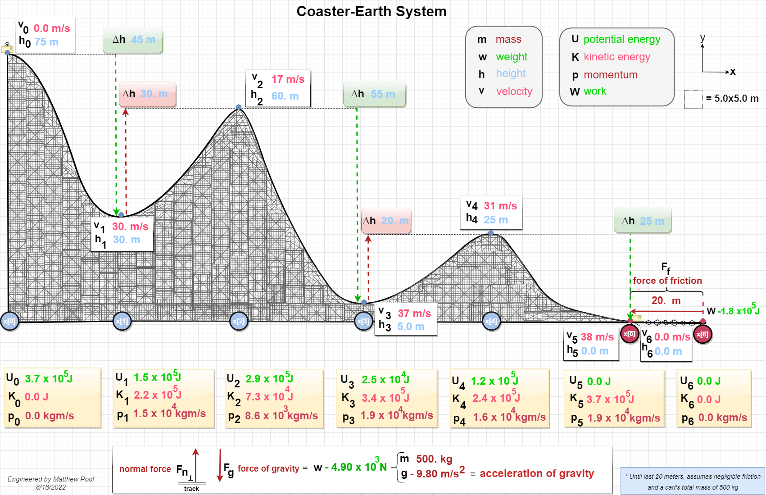

**CALCULATIONS**

***LEGEND***

$$'=prime \left(final value\right) \\ ∴ =therefore \\ ≡ =equivelant to \\ ∆ =Delta \left(difference in final and initial values\right) \\ U=potential energy \left(due to height and gravity\right) \\ K=kinetic energy \left(energy of motion\right) \\ E=total energy \\ W=work \left(energy transferred\right) \\ W_{ct}=work on track from cart \\ W_{tc}=work on cart from track \\ F_{f}=force of friction \\ F_{f}=force of friction \\ F_{g}=force of gravity \\ F_{net}=net force \\ m=mass \\ h=height \\ s=displacement≡d \\ g=acceleration due to gravity \\ a=acceleration \\ u=initial velocity \\ v=final velocity \\ p=momentum$$

**Motion, Energy, and Momentum(Principles / Formulas)**

$$v^{2}=2as+u^{2}∴v=\sqrt{2gh+u^{2}}$$

***OR***

$$∆K=\frac{1}{2}mv^{2}-\frac{1}{2}mu^{2}≡\frac{1}{2}mv^{2}=-mgh+\frac{1}{2}mu^{2}∴v=\sqrt{2gh+u^{2}}$$

$$v=\sqrt{2gh+u^{2}}$$

$$p=mv$$

$$K=\frac{1}{2}mv^{2}$$

$$U=mgh$$

$$E=K+U$$

X[0]

✓

X[1]

✓

X[2]

✓

✓

X[3]

✓

✓

X[4]

✓

X[5]

✓

**DESCRIPTION**

X[0]

**At the initial drop, there is no kinetic energy or momentum since there is no motion yet.**

**Potential energy is dependent on height, so potential energy is at its maximum here for this system because the force of gravity pulls downward towards the Earth. This potential energy of the amount $3.7 x 10^{5} J$ should be the net energy throughout the entire ride, since energy in a system is always conserved (unless acted upon by an outside force) and can only be transformed or transferred. And since we are assuming friction to be negligible, no energy is converted to heat or sound. So, the total energy of the cart-Earth system will be conserved!**

X[0]-x[1]

**Velocity and momentum increase, as the cart goes downhill on the track. The kinetic energy increases as well (since both are proportional to velocity), and potential energy reciprocates by decreasing.**

x[1]

**At the bottom of the initial drop, kinetic energy and momentum will now be at their highest – potential energy at its lowest.**

X[1]-x[2]

**Now headed uphill on the track, kinetic energy and momentum are decreasing and potential energy is increasing by the same proportion. But what about the momentum? It appears to have gone down. That’s because its dependent on velocity. The momentum will always be conserved in a system unless acted upon by an outside force. In this case, it’s the force of**

**gravity from Earth that is decelerating the cart, thus lowering the cart’s momentum. So, the conservation of momentum still holds up!**

x[2]

**At the top of the hill, potential energy of the cart does not reach quite as high as it initially was, since its height is now lower than that. There is still kinetic energy, since the cart is still in motion. Also, there is an instant at the top of the hill, where the force of gravity has no affect on the cart, since it is briefly perpendicular to the motion of the cart.**

**Something to point out is that the normal force from the track never does any work on the cart, since it is perpendicular to the motion of the cart at all times.**

x[3]

**Momentum and kinetic energy are now at their highest (so far), while potential energy is at its lowest, since its relative height is the lowest now as well.**

x[4]

**There is a gain in potential energy and a decrease in kinetic energy and momentum, since velocity has dropped, now that the cart is on top of another peak.**

x[4]-x[5]

**Down the final slope of the track, potential energy decreases to zero upon reaching ground-level. Velocity, and thus kinetic energy and momentum are at their absolute highest now!**

x[5]

**This is ground-level, where cart A will impact cart B, and then begin slowing to a stop, due to the force of friction.**

**Inelastic Collision**

**Energy and Momentum (Principles / Formulas)**

***Kinetic Energy***

$$K^{'}<K$$

$$K_{net}=K_{A}+K_{B}=\frac{1}{2}m_{A}v_{A}^{2}+\frac{1}{2}m_{B}v_{B}^{2}$$

***M******omentum***

**(Unless acted upon by an external force):**

$$p^{'}=p≡{p^{'}}_{A}+{p^{'}}_{B}=p_{A}+p_{B}≡m_{A}v_{A}+m_{B}v_{B}=m_{A}{v'}_{A}+m_{B}{v'}_{B}$$

***Velocity***

$$m_{A}v_{A}+m_{B}v_{B}=m_{A}{v'}_{A}+m_{B}{v'}_{B}∴v^{'}=v\left(\frac{m_{A}}{m_{A}+m_{B}}\right)$$

x[5]

Before:

$$K=\frac{1}{2}\left(500. kg\right){\left(38.340578\frac{m}{s}\right)}^{2}+\frac{1}{2}\left(500. kg\right){\left(0\right)}^{2}=367.499.98 J≅3.7 x 10^{5} J ≡ K_{A}$$

$$p=\left(500.kg\right)\left(38.34057\frac{m}{s}\right)+\left(500.kg\right)\left(0\right)=19,179.289\frac{kg\left(m\right)}{s}≅1.9 x 10^{4}\frac{kg\left(m\right)}{s}$$

After:

$$v^{'}=v\left(\frac{m_{A}}{m_{A}+m_{B}}\right)=38.340578\frac{m}{s}\left(\frac{500.kg}{500. kg+500. kg}\right)=19.170289\frac{m}{s}≅19\frac{m}{s}$$

$${K^{'}}_{A}=\frac{1}{2}m_{A}{v'}_{A}^{2}=\frac{1}{2}\left(500. kg\right){\left(19.170289\frac{m}{s}\right)}^{2}=91,874.9951 J≅9.2 x 10^{4} J$$

$${K^{'}}_{B}=\frac{1}{2}m_{B}{v^{'}}_{B}^{2}=\frac{1}{2}\left(500. kg\right){\left(19.70289\frac{m}{s}\right)}^{2}=91,874.9951 J≅9.2 x 10^{4} J$$

$${K^{'}}_{net}={K^{'}}_{A}+{K^{'}}_{B}=183,749.99 J≅1.8 x 10^{5} J$$

$$∆K=K^{'}-K=\left(183,749.99 J\right)-\left(367,499.98 J\right)= -183,749.99 J≅-1.8 x 10^{5} J$$

$$p^{'}=m_{A}{v'}_{A}+m_{B}{v'}_{B}=\left(500. kg\right)\left(19.1702893\frac{m}{s}\right)+\left(500. kg\right)\left(19.1702893\frac{m}{s}\right)=19,170.2893\frac{kg\left(m\right)}{s}≅1.9 x 10^{4}\frac{kg\left(m\right)}{s}$$

**Fused-Cart-Earth System**

x[5]

**A roller coaster uses gravity and inertia (defined in Newton’s first law of motion) to accelerate. Although, in a loop (not present here), centripetal force pushes riders inwards toward the center of the loop. Before the collision, cart A’s kinetic energy was around $3.7 x 10^{5} J$ and cart B at $0.0 J$ (since it was at rest) giving it a total energy of $3.7 x 10^{5} J$ (as it has been since the initial drop). Since the carts are of equal mass, when cart A impacts cart B, the velocity and kinetic energy of cart A will be cut in half, and that will then be the velocity and kinetic energy of the newly-fused carts. The collision should (realistically) lose some kinetic energy, due to transformation to heat, sound, and (possibly) material deformation, but we have been considering friction to be negligible up to this point.**

**The law of conservation of energy still applies, since cart B acted as an external force on cart A, because (as Newton’s first law of motion tells us) an object in motion (or at rest) will stay in motion (or at rest), respectively, until acted upon by an external force. His third law of motion also states that every force will be met with a reactive force of equal magnitude and opposite direction.**

**The net momentum of the fused carts is the same as it was before the impact, as the principle of conservation of momentum tells us.**

**Motion, Energy, and Work by Friction (Principles / Formulas)**

**Acceleration**

$$v^{2}=2as+u^{2}∴a=\frac{v^{2}-u^{2}}{2s}$$

**Newton’s Second Law**

$$F_{net}=ma$$

**Newton’s Third Law**

$$F_{applied}={-F}_{reactive}$$

$$∴m_{A}a_{A}={-m}_{B}a_{B}$$

**Work-Energy Theorem**

$$W_{net}=K^{'}-K=∆K=F_{net}s\left(cos θ\right)=F_{net}s\left(-1\right)=-Fs$$

$$K_{cart}=W_{ct}=F_{ct}s=-F_{tc}s=-mas$$

**Cart-Track System**

x[5]-x[6]

**Acceleration (negative = deceleration)**

$$a=\frac{v^{2}-u^{2}}{2s}=\frac{{\left(0\right)}^{2}-{\left(19.170289\frac{m}{s}\right)}^{2}}{2\left(20. m\right)}=-9.187499\frac{m}{s^{2}}≅-9.2\frac{m}{s^{2}}$$

**Work Done (negative = kinetic energy removed)**

$$W_{f}=-mas=-\left(1000 kg\right)\left(9.187499\frac{m}{s^{2}}\right)\left(20. m\right)=-183,749.98 N\left(m\right)≡J≅-1.8 x 10^{5} J$$

**Energy Transformations**

**Start of Frictional Track (**x[5]**)**

$$K=183, 749.99 J≅1.8 x 10^{5} J$$

$$U=0.0 J$$

$$E_{mechanical(potential,kinetic)}=183,749.99 J≅1.8 x 10^{5} J$$

**End of Frictional Track (**x[6]**)**

$$K'=0.0 J$$

$$U'=0.0 J$$

$${E^{'}}_{thermal,sound,deformation}=183,749.99 J≅1.8 x 10^{5} J$$

**DESCRIPTION**

X[5]-x[6]

**When the 1,000 kg fused-cart starts to slow down, its initial kinetic energy is about $1.8 x 10^{5} J.$ By the time the force of friction stops it, the kinetic velocity of the cart is zero, since there is no motion at all.**

**And because the fused-cart is at ground level (and on a horizontal plane), the force of gravity can have no effect on the cart’s motion; therefore, there is no potential energy either.**

**So, considering the law of conservation of energy and the fact that energy cannot be created or destroyed, where did all that energy go?**

**The surfaces of the cart and of the frictional section of the track allow the cart to stop within a 20-meter stretch by transforming the kinetic energy (from its motion) into thermal energy, sound, and material deformations. So, the frictional track will be worn down a little bit, and there will obviously be a sound produced as well. And though you may not be able to tell, the ambient temperature may go up a fraction of a degree. And though the momentum of the cart is now zero, the law of conservation of momentum still holds up, as the force of friction is an external force upon the cart. The momentum has only been taken in by the track and the Earth, through a (practically) limitless chain reaction of opposing forces and recoil.**

**Sort of beautiful.**